**AGENDA FOR THE**

**MEETING**

**OF THE**

**KINGSPORT HISTORIC ZONING COMMISSION**

March 8th, 2021 1:30 P.M.

Council Room in City Hall

Meeting via Zoom

I. Introduction and Recognition of Visitors

**MEETING PROCEDURES**

A determination by the Board that meeting electronically and limiting the physical presence of the public at the meeting is necessary to protect public health, safety, and welfare, of all concerned in light of the Covid-19 virus.

At this time, Chairman Harmon extends a welcome to all visitors. Time will be allowed at the conclusion of the meeting for public comment.

II. Old Business:

1. Approval of the Sept. 14th, 2020 minutes

III. New Business:

1. New member – Welcome Rev. Jack Edwards!
2. Applicant presents 2000 Netherland Inn Road project
3. 278 Hammond Ave. – New window installment
4. 2248 Netherland Inn Rd. – Yard barn in rear of house
5. Update from Commissioner Beverly about PC
6. Church Circle Repairs

IV. Other Business:

1. 201 West Sullivan St. In-house approval (driveway) (Oct. 2020)
2. 109 Shelby St. mural –decided to change location (Nov. 2020)
3. 1008 Rotherwood Rd – new fence (Nov. 2020)
4. 2244 Netherland Inn Rd – Yard barn in rear yard (Nov. 2020)
5. 2122 Netherland Inn Rd – Century 21 sign (Dec. 2020)
6. 151 E. Main St. – roof and structure to cover outdoor patio area (Jan. 2021)
7. 2244 Netherland Inn Rd – front porch on the yard barn that is behind the home (Feb. 2021)

Adjournment

**MINUTES OF THE REGULARLY SCHEDULED MEETING OF THE**

**KINGSPORT HISTORIC ZONING COMMISSION**

September 14th, 2020 1:30 p.m.

**Members Present**  **Members Absent**

Jason Meredith Liza Harmon

Jewell McKinney Dineen West

Beverly Perdue

Dr. Erin Reid

Liza Howle

**Staff Present Visitors Present**

Savannah Garland Maurice Ivey

Ken Weems Lauren Ivey

Historic Zoning Commission (HZC) Jason Meredith, opened the meeting at 1:30 p.m. Meredith thanked the commissioners for attending the regular scheduled meeting and welcomed the visitors. Since the Chairman and Vice Chair were out of town Jason Meredith was asked to lead the meeting. Meredith then asked for an approval of the minutes from the August meeting. On a motion by Commissioner Jewell, seconded by Commissioner Dr. Reid the August meeting minutes were approved.

Under “New Business” the commission discussed the certificate of approval for 222 W. Wanola Ave. Garland gave some background about the project and explained why it went unnoticed by the City as fences do not require permits. Garland asked the visitors if they had any comments or anything they wanted to share about their fence. The visitors were very compliant and explained they did not realize they were in a Historical Zone. Mr. Ivey explained the purpose of the fence was to protect their kids when in the backyard as they’ve has a stranger come up to the house window before. Howel noticed the other wooden fences in the Park Hill district, but what sticks out about this particular fence is that it goes all the way to the sidewalk and the color does not match the house. Perdue and Dr. Reid suggested painting the fence to match the house. Meredith brought up a good point that other than aesthetics there is no setback requirements for fences. The visitors stated that there was a miscommunication with the company they hired to do the fence and the fence was not supposed to go all the way to the sidewalk to begin with. It was agreed upon with the Commissioners and the visitors to move the fence back from the sidewalk to where it is aligned with the house and painted to match the house. McKinney made the motion to approve the relocation and painting of the fence and Howel seconded it. Next under “New Business” is the 2122 Netherland Inn road application. The applicants were unable to attend. After discussing the project the Commissioners felt comfortable in approving the project as all the updates the applicant was wanting to make follow the Historical Zoning Guidelines. McKinney made a motion to approve 2122 Netherland Inn and Perdue seconded. Perdue then gave a brief update on Planning Commission. Next, was the review and discussion of the Historical Zoning District letters. Garland explained the letters will be sent out once the Planning Department moves into the new office space. This way the letters can have the correct office address and conference room on it. Howel also suggested adding a picture or watermark of the Historical District they reside in in each letter.

Next, under “Other Business” was the discussion of the “In-House” approvals that took place. The first being 2301 Netherland Inn road and the second being 211 W. Wanola Ave. Meredith wanted to address what qualifies as an “In-House” approval. Garland referred to the guidelines and read what was qualified to be an “In-House” approval. Meredith expressed his concern about new structures being “In-House” approved. Meredith brought up that new structures are not simple cosmetic fixtures and should probably be brought to the Commissioners for further discussion. Garland asked Ken Weems to share his thoughts about adding the City Archivist to the HZC as a voting member. Weems brought up having the City Archivist as a voting ex-officio member. Weems then shared examples of other City employees who are ex-officio voting members on other boards, including himself.

No one spoke during public comment.

There being no further business the meeting adjourned at 2:20pm.

Respectfully Submitted,

_______________________

Liza Harmon, Chairman

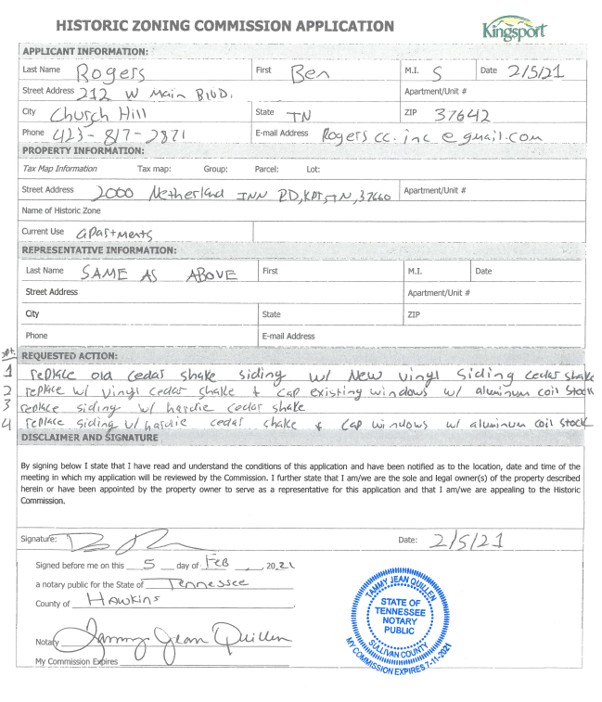

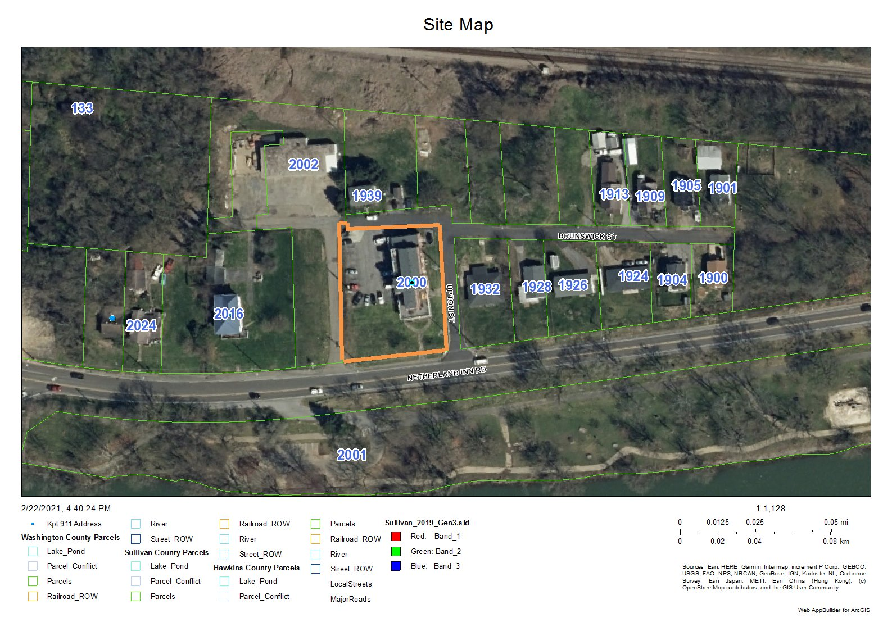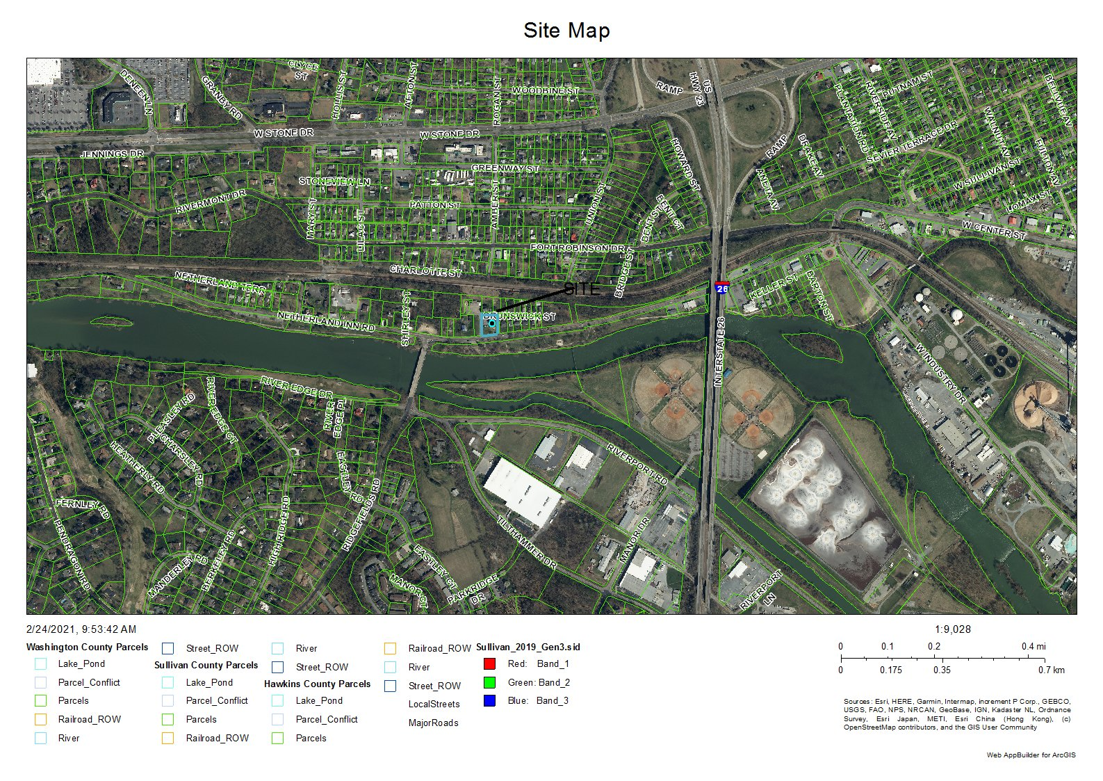

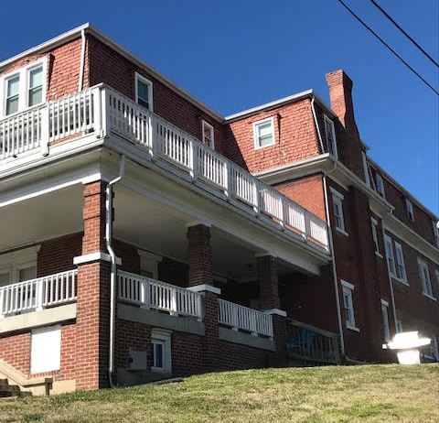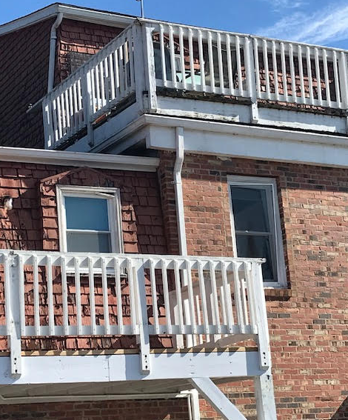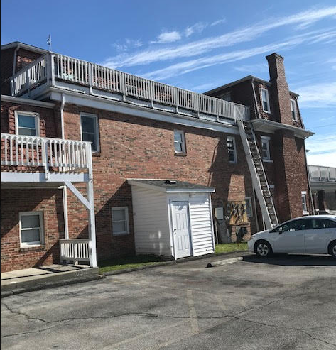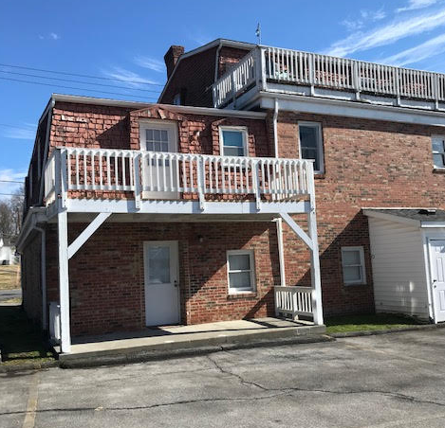

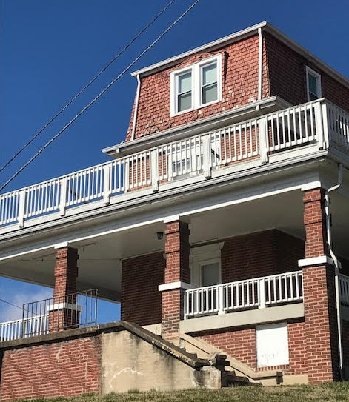

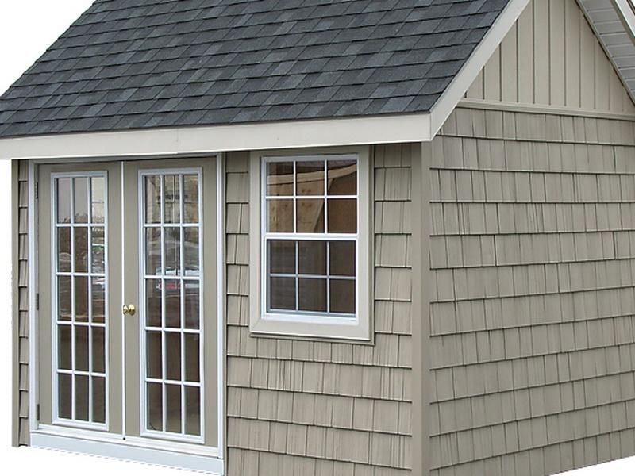**New Proposed Vinyl Cedar Shake below to match the existing color.**